Name : Shaik Hapsa
Roll No : 26000130
Branch : CSE
Section : 2

1. Topic Name : College Information and Admissions Website

Aim:
To design a college website using HTML and CSS to display college information, departments, faculty profiles, admissions, facilities, events, and contact details.
Description:
This project is a simple college website developed using HTML and CSS. HTML is used to create the structure of the website, while CSS is used to add colors, spacing, borders, and alignment. The website contains different sections to provide information about the college in an organized manner.
Main Features:
- Header: Displays the college name and tagline.
- Navigation Bar: Provides links to different sections of the website.
- Banner: Displays a welcome message and admission link.
- About Section: Gives a brief introduction to the college.
- Departments: Displays courses such as CSE, Electronics, and Mechanical Engineering.
- Faculty Profiles: Shows faculty names and their designations.
- Admissions: Explains the admission procedure in three steps.
- Facilities: Displays the library, computer labs, and hostel.
- Events: Provides information about technical fests and cultural activities.
- Contact Section: Displays email, phone number, and address.
- Footer: Shows the copyright information.

HTML and CSS Used
Tag / Property | Purpose
<html> | Defines the HTML document.
<head> | Contains the title and CSS styles.
<title> | Sets the webpage title.
<body> | Contains the visible webpage content.
<div> | Groups related content into sections.
<h1>, <h2>, <h3> | Display headings of different levels.
<p> | Displays paragraphs.
<a> | Creates links for navigation.
<ul> and <li> | Display lists of courses.
background-color | Sets the background color.
color | Changes text color.
padding | Adds space inside an element.
margin | Adds space outside an element.
text-align | Aligns text.
border | Adds a border around cards.
display: inline-block | Places cards side by side.

Conclusion
This project demonstrates how HTML and CSS can be used to create a simple, attractive, and well-organized college website. It helps students understand webpage structure, navigation links, styling, and card layouts.

Output :

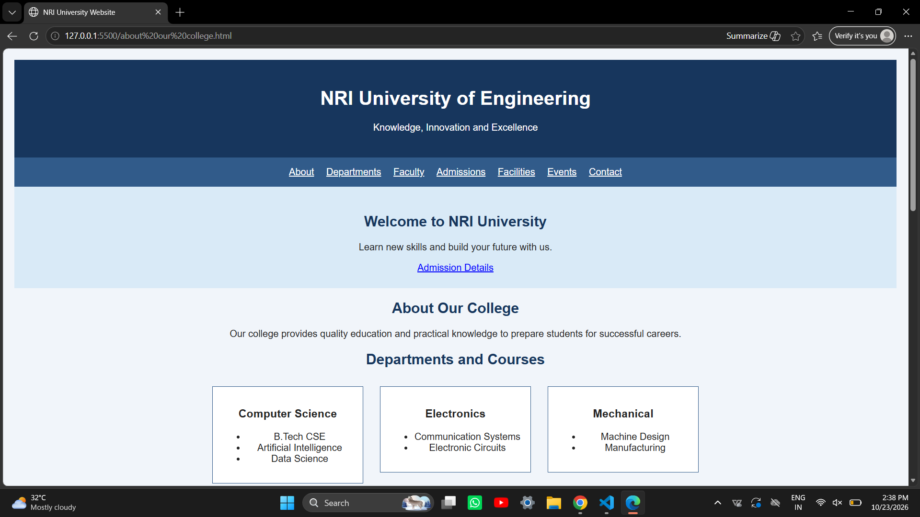

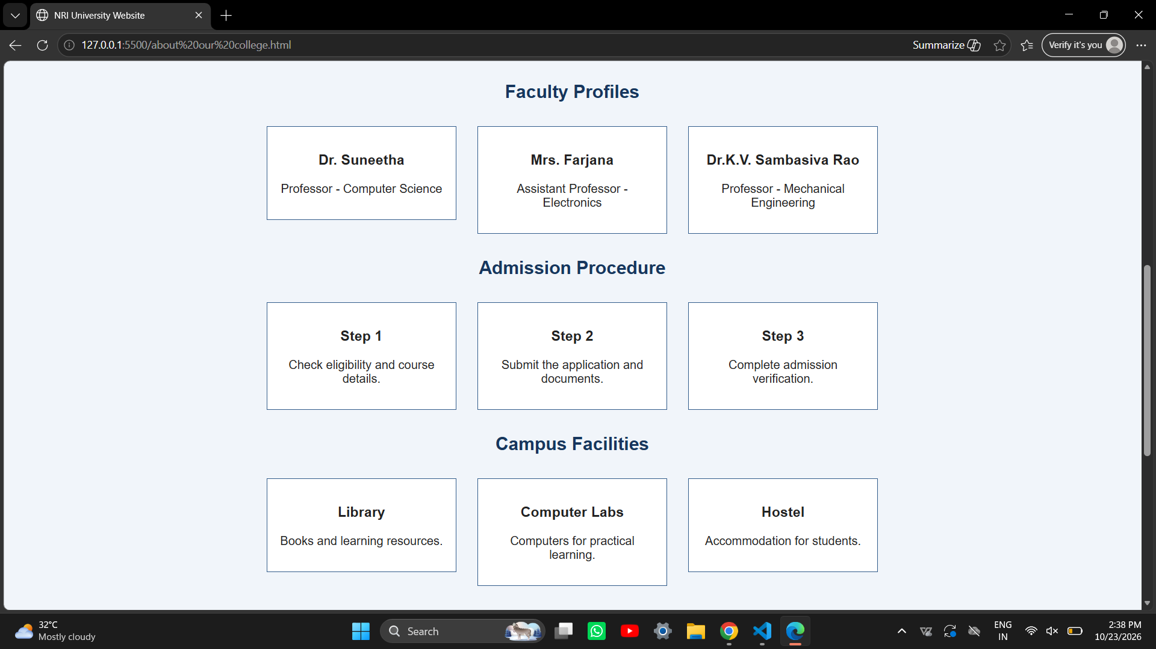

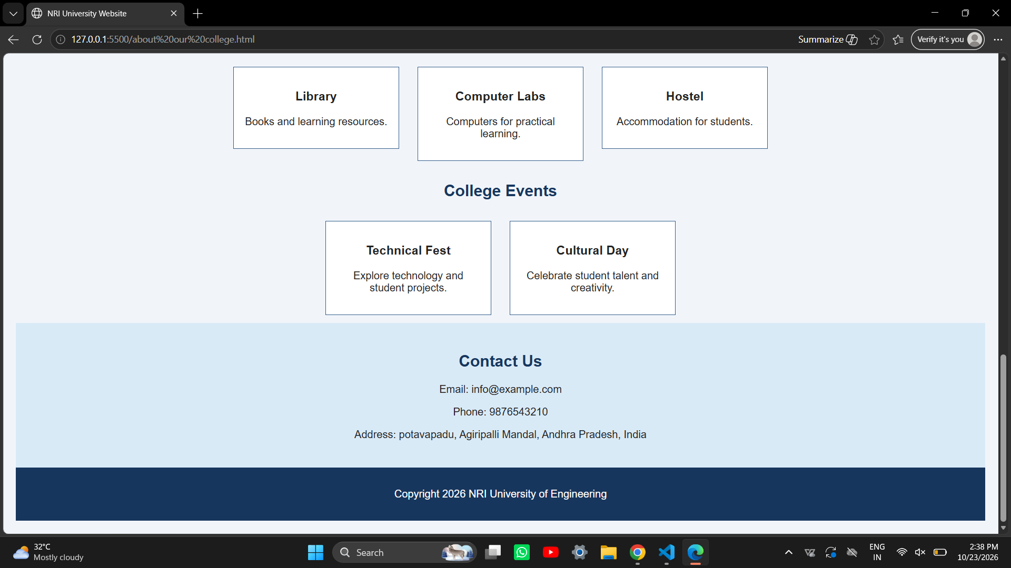
2. Topic Name : Online Shopping Website

Aim
To design an online shopping website using HTML and CSS to display product categories, product details, prices, ratings, discounts, and contact information.

Description
This project is a simple online shopping website named ShopEasy. HTML is used to create the structure of the webpage, and CSS is used to style the website with colors, spacing, alignment, and borders. It displays different products with their prices, ratings, discounts, and Buy Now links.

Main Features
- Header: Displays the ShopEasy store name and tagline.
- Navigation Bar: Provides links to Home, Categories, Products, Offers, and Contact.
- Banner: Displays the shopping festival message and Shop Now link.
- Product Categories: Shows Electronics, Fashion, Footwear, and Accessories.
- Products Section: Displays smartphones, headphones, and smart watches.
- Price and Rating: Shows product prices and customer ratings.
- Discounts: Displays offers available on different products.
- Buy Now: Provides a link to the contact section.
- Special Offers: Displays information about shopping discounts.
- Contact Section: Shows the store's email address and phone number.
- Footer: Displays copyright information.

HTML and CSS Used
Tag / Property | Purpose
<html> | Defines the HTML document.
<head> | Contains the title and CSS styles.
<title> | Sets the webpage title.
<body> | Contains the visible webpage content.
<div> | Groups content into sections.
<h1>, <h2>, <h3> | Display headings.
<p> | Displays paragraphs and product details.
<a> | Creates navigation links.
background-color | Sets the background color.
color | Changes the text color.
padding | Adds space inside an element.
margin | Adds space outside an element.
text-align | Aligns text.
border | Adds borders around products.
display: inline-block | Arranges product cards side by side.
font-size | Changes the size of the price text.

Conclusion
This project demonstrates how HTML and CSS can be used to create a simple and attractive online shopping website. It helps students understand webpage design, navigation links, product cards, pricing, and styling.

Output :
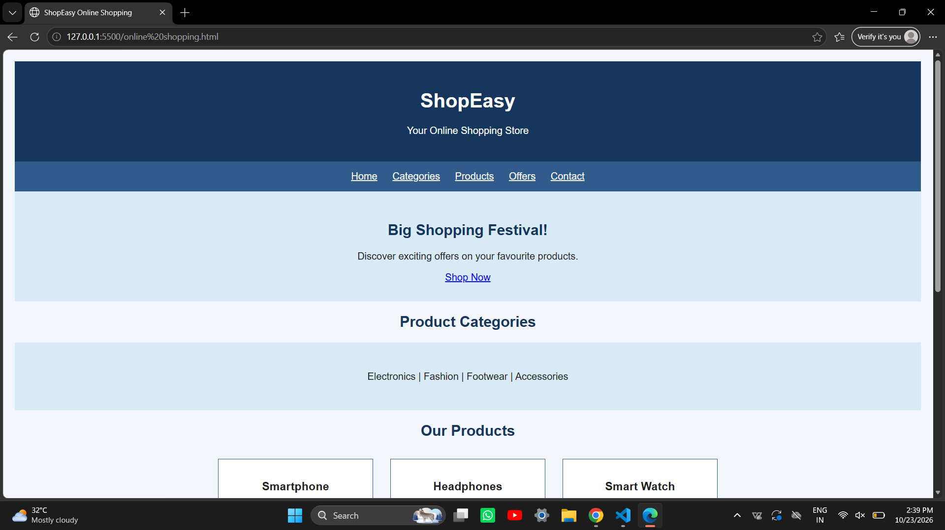

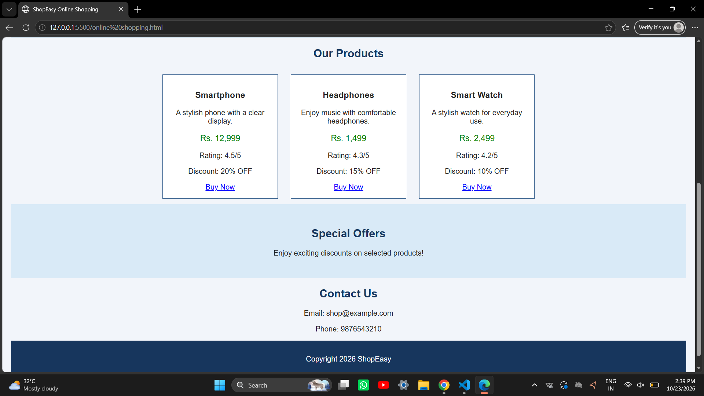
3. Topic Name : Restaurant and Cafe Website

Aim
To design a restaurant website using HTML and CSS to display the restaurant menu, food prices, chef profiles, ambience, customer reviews, and contact information.

Description
This project is a simple restaurant website named Royal Taste. HTML is used to create the structure of the webpage, while CSS is used to add colors, spacing, borders, and alignment. The website provides information about food items, their prices, chefs, restaurant ambience, customer reviews, and contact details.

Main Features
- Header: Displays the restaurant name and tagline.
- Navigation Bar: Provides links to Home, Menu, Chefs, and Contact.
- Welcome Banner: Displays a welcome message and View Menu link.
- Special Menu: Shows Pizza, Biryani, and Cappuccino with their prices.
- Chef Profiles: Displays chef names and their areas of expertise.
- Restaurant Ambience: Describes the seating, interiors, and service.
- Customer Reviews: Displays customer feedback.
- Contact Section: Shows the restaurant's address, phone number, and email.
- Footer: Displays copyright information.

HTML and CSS Used
Tag / Property | Purpose
<html> | Defines the HTML document.
<head> | Contains the title and CSS styles.
<title> | Sets the webpage title.
<body> | Contains the visible webpage content.
<div> | Groups content into sections.
<h1>, <h2>, <h3> | Display headings.
<p> | Displays descriptions and other text.
<a> | Creates navigation links.
background-color | Sets the background color.
color | Changes the text color.
padding | Adds space inside an element.
margin | Adds space outside an element.
text-align | Aligns text.
border | Adds borders around cards.
display: inline-block | Arranges cards side by side.
font-family | Sets the text style to Georgia.

Conclusion
This project demonstrates how HTML and CSS can be used to create a simple and attractive restaurant website. It helps students understand webpage structure, navigation links, menu cards, styling, and content organization.

Output :
